

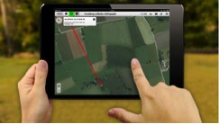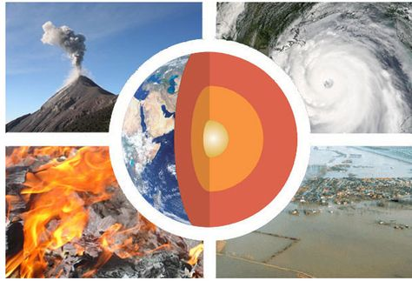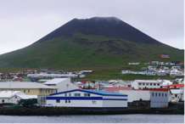

## What is Geography?

Geography is about understanding the world’s people, places and environments. It illuminates the past, explains the present and prepares us for the future. What can be more important than that?

Geography is one of the most popular option choices at GCSE with over a third of students in England taking the subject. Geography is not only up-to-date and relevant, it is one of the most exciting, adventurous and valuable subjects to study at GCSE level. So important, in fact, that the *Guardian* newspaper in 2015 named Geography as a ‘must-have GCSE and A-Level’ to help you make sense of the world.

If you are not sure about what you want to do in the future, Geography helps to keep your options open. It is a subject that goes well with the Sciences and Mathematics as well as the Humanities, Languages and Arts. It is very flexible in terms of what it can be combined with both at GCSE and A Level.

## What skills will I develop?

Almost too many to mention! There are so many ways of learning in Geography. It is very practical with opportunities to learn new skills such as modern computer based mapping (called GIS), digital technologies, map skills, interpreting photographs, analysing articles, decision-making and debating.

Fieldwork and trips are a really important part of Geography. You will learn how to investigate issues in the real world. You will improve your literacy through your report writing and written work and you will also learn how to put forward your own point of view and convince others that you are right!

You will make practical use of your numeracy skills when you interpret data and construct graphs. Your memory skills will also be boosted as you learn key memory techniques to help you remember case study information (facts and figures about places).

Such a wide variety of skills gained in Geography will be useful to you after you leave school. These skills are highly sought after by sixth form colleges, universities and employers.

## What syllabus will I follow?

AQA GCSE Geography (8035)

## What will the course look like?

The course is split into three sections:

**Unit 3 – Geographical Applications**

Fieldwork and an Issue Evaluation, which contains a decision making exercise based on a pre-release resources booklet made available 12 weeks before the Unit 3 exam.

**Unit 2 – Challenges in the Human Environment**

Urban Issues and Challenges including a study of London and Rio de Janeiro, Changing Economic World, Natural Resources

**Unit 1 – Living with the Physical Environment**

Natural Hazards, Ecosystems including Rainforests & Extreme Environments, and Coasts & Rivers

*Please turn over*

Head of Department: Mr D Burgess

*Adam, former Year 10 student*

*Geography is a subject like no other. It covers things other subjects can only dream of…*

## Fieldwork and Trips

As part of the course, you will take part in two pieces of fieldwork which will allow you to investigate different geographical issues.

Fieldwork for Unit 1 will be an investigation into river processes and flooding in Epping Forest.

Fieldwork for Unit 2 will be a day in East London, with a focus on the Olympic Park area.

The department is also keen to offer an optional international trip experience. In 2017, we visited Iceland and hiked to the top of an active volcano, bathed in hot geothermal pools naturally heated by the Earth, explored the ice on a glacier, saw some stunning waterfalls, went sightseeing in Reykjavik, and much more!

The department is investigating running a trip to Iceland, Italy or the Azores in 2019.

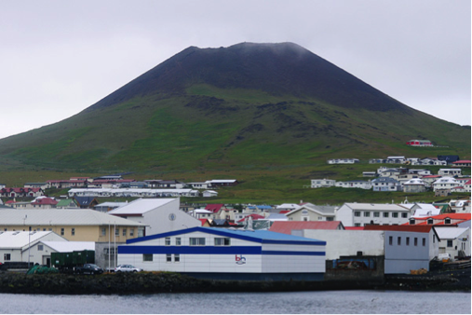

## What homework will I get?

Homework is set every week with a range of activities and challenges including reading, research, note-taking and practice examination questions.

## How will I be assessed?

There are three examinations at the end of Year 11:

* Unit 1 (1hr 30mins) tests Physical Geography (3 topics)
* Unit 2 (1hr 30mins) tests Human Geography (3 topics)
* Unit 3 (1hr 15mins) tests Fieldwork and contains a Decision Making Exercise

## What jobs or further courses of study might this lead to?

Students who have studied Geography have gone on to work in the following sectors: law, science, sales, business, environment, information technology, management, finance, banking, marketing, research, manufacturing, teaching, childcare, engineering and building, arts, design and media, town planning, working abroad and many (many) more…

## Are there any entry requirements for this course?

As the course is so broad, having good numeracy, literacy and scientific skills will be very important. If you choose Geography you must be prepared to work hard and be interested in the world around you. You will be required to develop and demonstrate a range of geographical skills, including the use of maps, numbers and statistics. Spelling, punctuation and grammar are assessed in all three examinations.

## If I need additional support, what can I access?

A wide range of support is available in Geography.

You will have access to a range of resources throughout the course. Many resources such as revision quizzes and games will be available online. The department offers revision/drop-in sessions in Year 10 and Year 11 to allow you to receive further advice and support. Revision guides are also available to purchase.